ICSR PREPARATION AND PROCESSING
CASE IDENTIFIERS:
1. Worldwide Unique Case Identifier - IN-TRNG-2026-000147
2. Case type – Spontaneous
3. Country of incidence – India
4. Date report first received (by company) – 03 Aug, 2026
5. Date of this follow-up - Initial report (no follow-up yet)
6. Seriousness – Serious
7. Seriousness criteria checked - Hospitalization (initial/prolonged); Medically significant
PRIMARY SOURCE(S) OF INFORMATION:
1. Reporter name - Dr. Kavitha Ramaswamy (contact details on file)
2. Qualification - Physician (Consultant-Internal Medicine)
3. Reporter type - Healthcare Professional (Primary source)
4. Affiliation - Department of Internal Medicine, tertiary care hospital, Chennai, Tamil Nadu
5. Country – India
6. Reporter's causality assessment - "Probable" (reporter's own words: "temporal relationship strong, improved on withdrawal")
7. Second-hand/nurse informant - Ms. Priya S., staff nurse, provided additional dosing timeline information

PATIENT CHARACTERISTICS:
1. Patient initials | R.K.
2. Age | 52 years
3. Sex | Female
4. Weight | 68 kg
5. Height | 158 cm
6. Ethnicity/Country | Indian
7. Relevant medical history | Type 2 diabetes mellitus (8 years, on oral hypoglycemics), hypertension (5 years), no known drug allergies previously documented
8. Relevant family history | Mother — hypertension; no known family history of drug hypersensitivity
9. Social history | Non-smoker, occasional alcohol use, no herbal/OTC supplement use reported
10. Pregnancy status | Not pregnant (postmenopausal)

REACTION/EVENT:
Reported Verbatim / Terminology
SYMPTOMS
1. Low grade fever
2. Erethematous maculopopular rash
3. Pruritis
4. Mild periorbital swelling
5. Mild facial oedema
6. Oral mucosal erosions
7. Tachycardia
DIAGNOSIS
1. Drug-induced hypersensitivity
2. Early Stevens-Johnson Syndrome
Standard MedDRA Terminology
Reported verbatim term | Suggested MedDRA Preferred Term (PT) | SOC
Low grade fever | Pyrexia | General disorders and administration site conditions
Erythematous maculopapular rash | Rash maculo-papular | Skin and subcutaneous tissue disorders
Pruritis | Pruritus | Skin and subcutaneous tissue disorders
Mild periorbital swelling | Periorbital oedema | Eye disorders
Mild facial oedema | Face oedema | General disorders and administration site conditions
Oral mucosal erosions | Mucosal erosion / Oral mucosal blistering depending on the exact documented concept | Skin and subcutaneous tissue disorders / Gastrointestinal disorders*
Tachycardia | Tachycardia | Cardiac disorders
Drug-induced hypersensitivity | Drug hypersensitivity | Immune system disorders
Early Stevens-Johnson Syndrome | Stevens-Johnson syndrome | Skin and subcutaneous tissue disorders
*The exact SOC/term placement can depend on the MedDRA version and the precise concept selected.
SUSPECTED DRUG DETAILS:
- Drug name (suspect #1) - Sulfamethoxazole/Trimethoprim (Co-trimoxazole) 800/160 mg
- Indication for use - Urinary tract infection (empirical therapy)
- Dose/frequency/route - 1 tablet (800/160 mg) twice daily, oral
- Start date - 22-Jul-2026
- Stop date - 29-Jul-2026 (discontinued on ADR onset)
- Duration of use prior to reaction - 7 days
- Batch/Lot number - Not provided by reporter (to be requested in follow-up)
- Action taken with drug - Drug withdrawn
- Dechallenge - Positive — rash and fever began resolving within 72 hours of withdrawal
- Rechallenge - Not done (contraindicated given reaction severity)
DRUG DETAILS (CONCOMITANT):
Drug | Indication | Dose | Start date | Ongoing
Metformin | T2DM | 500 mg BID, oral | ~2018 | Yes
Glimepiride | T2DM | 2 mg OD, oral | ~2018 | Yes
Amlodipine | Hypertension | 5 mg OD, oral | ~2021 | Yes
Paracetamol | Fever (symptomatic, self-medicated after rash onset) | 650 mg PRN, oral | 28-Jul-2026 | No (PRN)

NARRATICE CASE SUMMARY:
A 52-year-old woman with a history of type 2 diabetes and hypertension was prescribed co-trimoxazole 800/160 mg twice daily on 22-Jul-2026 for a culture-confirmed urinary tract infection. She remained well for the first five days. On Day 6, she developed a low-grade fever followed by a red, maculopapular rash that started on the trunk and gradually spread to both upper limbs. The rash became more widespread and was associated with itching, mild swelling around the eyes and facial oedema. She subsequently developed oral soreness with two small erosions on the buccal mucosa.
She was admitted on 29-Jul-2026 with fever, mild tachycardia and a widespread maculopapular rash with early target-like lesions. Mild facial oedema and two shallow oral erosions were also noted. There was no skin peeling, positive Nikolsky sign, or ocular/genital involvement. A drug-induced hypersensitivity reaction was considered, with early Stevens-Johnson syndrome included in the differential diagnosis because of the mucosal involvement.
Co-trimoxazole was considered the most likely causative drug based on the timing of the reaction and was stopped immediately. She received supportive treatment with IV fluids, cetirizine, topical emollients and a short course of oral prednisolone. Her regular medications, including metformin, glimepiride and amlodipine, were continued as they had been taken for several years without any previous reactions. Dermatology review supported the diagnosis of a co-trimoxazole-induced hypersensitivity reaction within the SJS spectrum.
Over the next few days, her condition improved. By 31-Jul-2026, the fever had settled, the rash was fading with some post-inflammatory hyperpigmentation, and the oral erosions were healing. She was discharged in a stable condition on 01-Aug-2026 and was advised to avoid sulfonamide antibiotics in the future. An allergy alert was also added to her medical records.
SEVERITY ASSESSMENT:
The patient was admitted to the hospital on 29-Jul-2026 and was discharged in a stable condition on 01-Aug-2026. The ADR was the reason for the admission and the length of stay was 3 to 4 days. There is no indication of intensive medical care. This indicates that the severity grade of the reaction in this case is, Severity Grade 4.
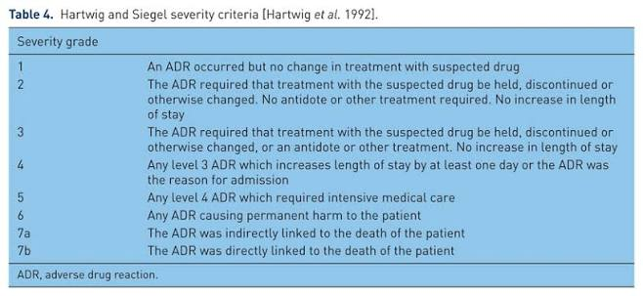
CAUSALITY ASSESSMENT:
NARANJO ALGORITHM
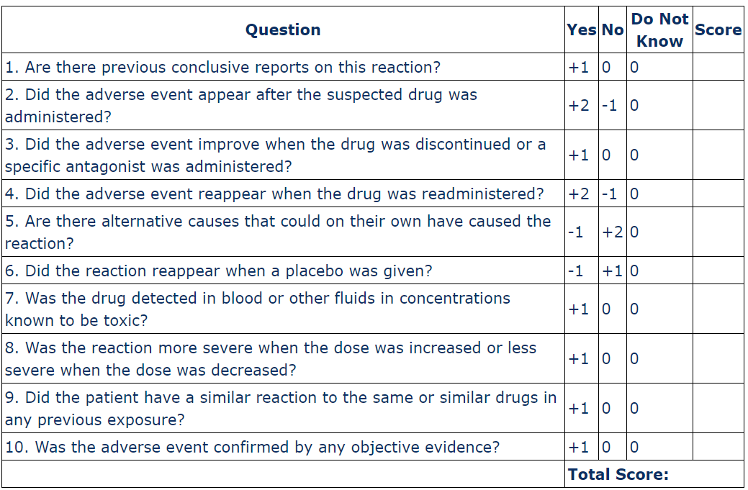
Total Score Interpretation:
- Definite: 9 points or higher
- Probable: 5 to 8 points
- Possible: 1 to 4 points
- Doubtful: 0 points or less

Calculation: 1 + 2 + 1 + 0 + 2 + 0 + 0 + 0 + 0 + 1 = 7

Causality – Probable.

